

STM CLICK AND COLLECT PRE-LOVED UNIFORM

|  |  |
| --- | --- |
| DATE: |  |
| PERSON REQUESTING ORDER: |  |
| CHILD/REN NAME: |  |
| CHILD/REN CLASS: |  |

* complete and return the order form to [admin@st-thomasmore.coventry.sch.uk](mailto:admin@st-thomasmore.coventry.sch.uk)
* you will be alerted when the order is ready for collection from the school office (if it is available)
* make payment (the correct cash) when you pick up your order from the school office

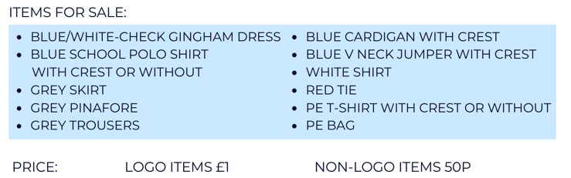

|  |  |  |  |  |
| --- | --- | --- | --- | --- |
| Item Description of item | Quantity | Size | Price | Total |
|  |  |  |  |  |
|  |  |  |  |  |
|  |  |  |  |  |
|  |  |  |  |  |
|  |  |  |  |  |
|  |  |  |  |  |
|  |  |  |  |  |
|  |  |  |  |  |
|  |  |  |  | **£** |